Geometric Equation

Definition
# Source: AI Source: Provided by: [Data Path: Persons Table -> ID Column: 1, Name_En Column: Motasem Essam] -> From: [ChatGPT] on [7/25/2026]
A Geometric Equation is a mathematical equation that represents a geometric object, quantity, relationship, property, or condition.
It uses an equality sign:
$$\boxed{=}$$
to state that two mathematical expressions represent the same value or satisfy the same geometric relationship.
For example:
$$\boxed{AB+BC=AC}$$
represents a segment-length relationship, while:
$$\boxed{{\left(x-h\right)}^{2}+{\left(y-k\right)}^{2}=r^{2}}$$
represents a circle in the coordinate plane.
Simple Definition
A Geometric Equation is an equation used to represent a geometric object, measurement, relationship, or condition.

Main Classification of Geometric Equations
# Source: AI Source: Provided by: [Data Path: Persons Table -> ID Column: 1, Name_En Column: Motasem Essam] -> From: [ChatGPT] on [7/25/2026]
A practical classification is:
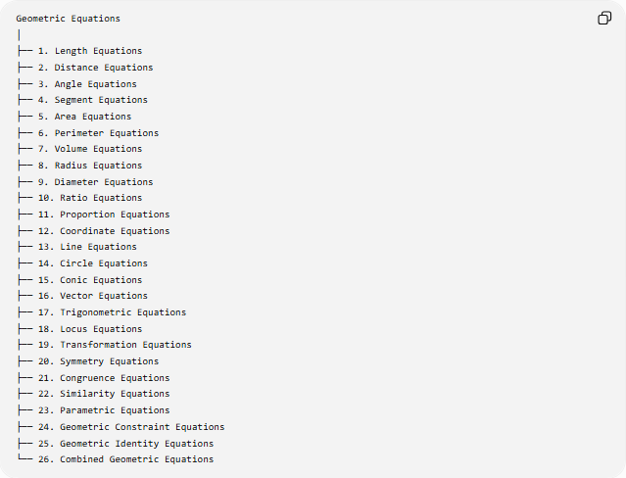
Geometric Equations
│
├── 1. Length Equations
├── 2. Distance Equations
├── 3. Angle Equations
├── 4. Segment Equations
├── 5. Area Equations
├── 6. Perimeter Equations
├── 7. Volume Equations
├── 8. Radius Equations
├── 9. Diameter Equations
├── 10. Ratio Equations
├── 11. Proportion Equations
├── 12. Coordinate Equations
├── 13. Line Equations
├── 14. Circle Equations
├── 15. Conic Equations
├── 16. Vector Equations
├── 17. Trigonometric Equations
├── 18. Locus Equations
├── 19. Transformation Equations
├── 20. Symmetry Equations
├── 21. Congruence Equations
├── 22. Similarity Equations
├── 23. Parametric Equations
├── 24. Geometric Constraint Equations
├── 25. Geometric Identity Equations
└── 26. Combined Geometric Equations
This is a practical classification, not a universally standardized taxonomy.

1. Length Equations
# Source: AI Source: Provided by: [Data Path: Persons Table -> ID Column: 1, Name_En Column: Motasem Essam] -> From: [ChatGPT] on [7/25/2026]
Definition
A Length Equation establishes equality between geometric lengths or expresses an unknown length.
Example
If a segment is divided at $B$:
$$\boxed{AB+BC=AC}$$
If:
$$AB=5, BC=7$$
then:
$$AC=5+7 \\ \boxed{AC=12}$$
Another example:
$$\boxed{AB=2x+3}$$
can be solved when additional information gives the value of $x$.

2. Distance Equations
# Source: AI Source: Provided by: [Data Path: Persons Table -> ID Column: 1, Name_En Column: Motasem Essam] -> From: [ChatGPT] on [7/25/2026]
Definition
A Distance Equation represents a specific distance relationship between geometric objects.
Point-to-Point Distance
For:
$$A\left(x_{1} , y_{1}\right), B\left(x_{2} , y_{2}\right) \\ \boxed{AB=\sqrt{{\left(x_{2}-x_{1}\right)}^{2}+{\left(y_{2}-y_{1}\right)}^{2}}}$$
Equal-Distance Equation
$$\boxed{PA=PB}$$
means that point $P$is equally distant from $A$and $B$.

3. Angle Equations
# Source: AI Source: Provided by: [Data Path: Persons Table -> ID Column: 1, Name_En Column: Motasem Essam] -> From: [ChatGPT] on [7/25/2026]
Definition
An Angle Equation establishes an equality involving angle measures.
Complementary Angles
$$\boxed{A+B={90}^{∘}}$$
Supplementary Angles
$$\boxed{A+B={180}^{∘}}$$
Triangle Angle Sum
$$\boxed{A+B+C={180}^{∘}}$$
Example
If:
$$A=2x+{10}^{∘}$$
and:
$$B=3x-{20}^{∘}$$
are complementary:
$$\left(2x+{10}^{∘}\right)+\left(3x-{20}^{∘}\right)={90}^{∘}$$

4. Segment Equations
# Source: AI Source: Provided by: [Data Path: Persons Table -> ID Column: 1, Name_En Column: Motasem Essam] -> From: [ChatGPT] on [7/25/2026]
Definition
A Segment Equation represents a relationship among line segments.
Midpoint
If $M$is the midpoint of $\overset{‾}{AB}$:
$$\boxed{AM=MB}$$
and:
$$\boxed{AM=MB=\frac{AB}{2}}$$
Example
If:
$$AB=14$$
then:
$$AM=MB=7$$

5. Area Equations
# Source: AI Source: Provided by: [Data Path: Persons Table -> ID Column: 1, Name_En Column: Motasem Essam] -> From: [ChatGPT] on [7/25/2026]
Definition
An Area Equation represents the area of a two-dimensional geometric figure.
Triangle
$$\boxed{A=\frac{1}{2}bh}$$
Rectangle
$$\boxed{A=lw}$$
Circle
$$\boxed{A=πr^{2}}$$
Example
For a triangle with:
$$b=8, h=5 \\ A=\frac{1}{2}\left(8\right)\left(5\right) \\ \boxed{A=20}$$

6. Perimeter Equations
# Source: AI Source: Provided by: [Data Path: Persons Table -> ID Column: 1, Name_En Column: Motasem Essam] -> From: [ChatGPT] on [7/25/2026]
Definition
A Perimeter Equation represents the total boundary length of a plane figure.
Rectangle
$$\boxed{P=2l+2w}$$
Triangle
$$\boxed{P=a+b+c}$$
Regular Polygon
$$\boxed{P=ns}$$
where $n$is the number of sides and $s$is the side length.

7. Volume Equations
# Source: AI Source: Provided by: [Data Path: Persons Table -> ID Column: 1, Name_En Column: Motasem Essam] -> From: [ChatGPT] on [7/25/2026]
Definition
A Volume Equation represents the amount of three-dimensional space occupied by a solid.
Rectangular Prism
$$\boxed{V=lwh}$$
Cylinder
$$\boxed{V=πr^{2}h}$$
Sphere
$$\boxed{V=\frac{4}{3}πr^{3}}$$
Cone
$$\boxed{V=\frac{1}{3}πr^{2}h}$$

8. Radius Equations
# Source: AI Source: Provided by: [Data Path: Persons Table -> ID Column: 1, Name_En Column: Motasem Essam] -> From: [ChatGPT] on [7/25/2026]
Definition
A Radius Equation represents a relationship involving a radius.
Since the diameter is twice the radius:
$$\boxed{d=2r}$$
Therefore:
$$\boxed{r=\frac{d}{2}}$$
From circumference:
$$C=2πr$$
so:
$$\boxed{r=\frac{C}{2π}}$$

9. Diameter Equations
# Source: AI Source: Provided by: [Data Path: Persons Table -> ID Column: 1, Name_En Column: Motasem Essam] -> From: [ChatGPT] on [7/25/2026]
Definition
A Diameter Equation represents a relationship involving a circle's or sphere's diameter.
$$\boxed{d=2r}$$
For a circle:
$$\boxed{C=πd}$$

10. Ratio Equations
# Source: AI Source: Provided by: [Data Path: Persons Table -> ID Column: 1, Name_En Column: Motasem Essam] -> From: [ChatGPT] on [7/25/2026]
Definition
A Ratio Equation states that two ratios are equal.
For example:
$$\boxed{\frac{AB}{CD}=\frac{EF}{GH}}$$
Example
If:
$$\frac{x}{6}=\frac{4}{3}$$
then:
$$3x=24 \\ \boxed{x=8}$$

11. Proportion Equations
# Source: AI Source: Provided by: [Data Path: Persons Table -> ID Column: 1, Name_En Column: Motasem Essam] -> From: [ChatGPT] on [7/25/2026]
Definition
A Proportion Equation expresses equality between two ratios.
A common geometric example occurs in similar triangles:
$$\boxed{\frac{AB}{DE}=\frac{BC}{EF}}$$
Example
If:
$$\frac{x}{10}=\frac{6}{15}$$
then:
$$15x=60$$
so:
$$\boxed{x=4}$$

12. Coordinate Equations
# Source: AI Source: Provided by: [Data Path: Persons Table -> ID Column: 1, Name_En Column: Motasem Essam] -> From: [ChatGPT] on [7/25/2026]
Definition
A Coordinate Equation represents a geometric object or relationship using coordinates.
Examples include equations for:
- points
- lines
- circles
- parabolas
- ellipses
- hyperbolas
For example:
$$\boxed{x^{2}+y^{2}=25}$$
represents a circle centered at the origin with radius $5$.
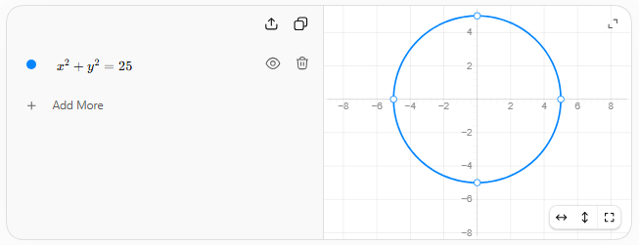

13. Line Equations
# Source: AI Source: Provided by: [Data Path: Persons Table -> ID Column: 1, Name_En Column: Motasem Essam] -> From: [ChatGPT] on [7/25/2026]
Definition
A Line Equation represents a straight line in a coordinate system.
Slope-Intercept Form
$$\boxed{y=mx+b}$$
where:
- $m$= slope
- $b$= $y$-intercept
Example
$$\boxed{y=2x+1}$$
represents a line with slope $2$.
Point-Slope Form
$$\boxed{y-y_{1}=m\left(x-x_{1}\right)}$$
Standard Form
$$\boxed{Ax+By=C}$$

14. Circle Equations
# Source: AI Source: Provided by: [Data Path: Persons Table -> ID Column: 1, Name_En Column: Motasem Essam] -> From: [ChatGPT] on [7/25/2026]
Definition
A Circle Equation represents a circle in a coordinate plane.
The standard equation is:
$$\boxed{{\left(x-h\right)}^{2}+{\left(y-k\right)}^{2}=r^{2}}$$
where:
- $\left(h , k\right)$= center
- $r$= radius
Example
$$\boxed{{\left(x-2\right)}^{2}+{\left(y+3\right)}^{2}=16}$$
has:
$$\text{center}=\left(2 , -3\right)$$
and:
$$\boxed{r=4}$$

15. Conic Equations
# Source: AI Source: Provided by: [Data Path: Persons Table -> ID Column: 1, Name_En Column: Motasem Essam] -> From: [ChatGPT] on [7/25/2026]
Definition
Conic Equations represent the four principal conic sections:
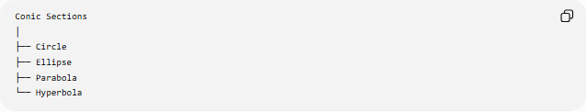
Conic Sections
│
├── Circle
├── Ellipse
├── Parabola
└── Hyperbola
Circle
$$\boxed{x^{2}+y^{2}=r^{2}}$$
Ellipse
$$\boxed{\frac{x^{2}}{a^{2}}+\frac{y^{2}}{b^{2}}=1}$$
Parabola
$$\boxed{y^{2}=4px}$$
Hyperbola
$$\boxed{\frac{x^{2}}{a^{2}}-\frac{y^{2}}{b^{2}}=1}$$

16. Vector Equations
# Source: AI Source: Provided by: [Data Path: Persons Table -> ID Column: 1, Name_En Column: Motasem Essam] -> From: [ChatGPT] on [7/25/2026]
Definition
A Vector Equation represents a geometric object or relationship using vectors.
A line can be represented parametrically by:
$$\boxed{\vec{r}={\vec{r}}_{0}+t\vec{v}}$$
where:
- ${\vec{r}}_{0}$= a point on the line
- $\vec{v}$= direction vector
- $t$= parameter
Example
$$\boxed{\vec{r}=\left\langle 1 , 2\right\rangle +t\left\langle 3 , 4\right\rangle }$$
represents a line passing through $\left(1 , 2\right)$in direction $\left\langle 3 , 4\right\rangle$.

17. Trigonometric Equations
# Source: AI Source: Provided by: [Data Path: Persons Table -> ID Column: 1, Name_En Column: Motasem Essam] -> From: [ChatGPT] on [7/25/2026]
Definition
A Trigonometric Equation represents geometric relationships using trigonometric functions.
Right Triangle
$$\boxed{\sin{θ}=\frac{\text{opposite}}{\text{hypotenuse}}}$$
Law of Sines
$$\boxed{\frac{a}{\sin{A}}=\frac{b}{\sin{B}}=\frac{c}{\sin{C}}}$$
Law of Cosines
$$\boxed{c^{2}=a^{2}+b^{2}-2ab\cos{C}}$$
These equations connect side lengths and angles.

18. Locus Equations
# Source: AI Source: Provided by: [Data Path: Persons Table -> ID Column: 1, Name_En Column: Motasem Essam] -> From: [ChatGPT] on [7/25/2026]
Definition
A Locus Equation represents the set of points satisfying a geometric condition.
Circle Locus
Points at fixed distance $r$from $\left(h , k\right)$:
$$\boxed{{\left(x-h\right)}^{2}+{\left(y-k\right)}^{2}=r^{2}}$$
Perpendicular Bisector
For two points $A$and $B$, the condition:
$$\boxed{PA=PB}$$
defines the perpendicular bisector of $\overset{‾}{AB}$.
Parabola
A parabola can be defined by:
$$\boxed{PF=d\left(P , l\right)}$$
where $F$is the focus and $l$is the directrix.

19. Transformation Equations
# Source: AI Source: Provided by: [Data Path: Persons Table -> ID Column: 1, Name_En Column: Motasem Essam] -> From: [ChatGPT] on [7/25/2026]
Definition
A Transformation Equation represents how coordinates change under a geometric transformation.
Translation
$$\boxed{\left(x , y\right)→\left(x , +ay+b\right)}$$
Reflection Across the $x$-Axis
$$\boxed{\left(x , y\right)→\left(x , -y\right)}$$
${90}^{∘}$Counterclockwise Rotation
$$\boxed{\left(x , y\right)→\left(- , yx\right)}$$
Dilation
$$\boxed{\left(x , y\right)→\left(k , xky\right)}$$

20. Symmetry Equations
# Source: AI Source: Provided by: [Data Path: Persons Table -> ID Column: 1, Name_En Column: Motasem Essam] -> From: [ChatGPT] on [7/25/2026]
Definition
A Symmetry Equation represents a geometric condition associated with symmetry.
For example, reflection across the $y$-axis maps:
$$\boxed{\left(x , y\right)→\left(- , xy\right)}$$
A figure has reflection symmetry about a line $l$when:
$$\boxed{R_{l}\left(F\right)=F}$$

21. Congruence Equations
# Source: AI Source: Provided by: [Data Path: Persons Table -> ID Column: 1, Name_En Column: Motasem Essam] -> From: [ChatGPT] on [7/25/2026]
Definition
A Congruence Equation expresses equality between corresponding geometric quantities.
For congruent triangles:
$$△ABC≅△DEF$$
corresponding sides satisfy:
$$\boxed{AB=DE} \\ \boxed{BC=EF} \\ \boxed{AC=DF}$$
and corresponding angles are equal.

22. Similarity Equations
# Source: AI Source: Provided by: [Data Path: Persons Table -> ID Column: 1, Name_En Column: Motasem Essam] -> From: [ChatGPT] on [7/25/2026]
Definition
A Similarity Equation represents proportionality between corresponding measurements of similar figures.
For similar triangles:
$$\boxed{\frac{AB}{DE}=\frac{BC}{EF}=\frac{AC}{DF}}$$
If the scale factor is $k$:
$$\boxed{\text{new length}=k\left(\text{original length}\right)}$$
For areas:
$$\boxed{\text{new area}=k^{2}\left(\text{original area}\right)}$$

23. Parametric Equations
# Source: AI Source: Provided by: [Data Path: Persons Table -> ID Column: 1, Name_En Column: Motasem Essam] -> From: [ChatGPT] on [7/25/2026]
Definition
A Parametric Equation represents a geometric object using one or more parameters.
Line
$$\boxed{x=x_{0}+at} \\ \boxed{y=y_{0}+bt}$$
Circle
$$\boxed{x=h+r\cos{t}} \\ \boxed{y=k+r\sin{t}}$$
Parametric equations are especially useful for curves, paths, and trajectories.

24. Geometric Constraint Equations
# Source: AI Source: Provided by: [Data Path: Persons Table -> ID Column: 1, Name_En Column: Motasem Essam] -> From: [ChatGPT] on [7/25/2026]
Definition
A Geometric Constraint Equation expresses a required condition that restricts the possible configurations of geometric objects.
Examples
Equal lengths:
$$\boxed{AB=CD}$$
Perpendicularity:
$$\boxed{l_{1}⊥l_{2}}$$
Equal distances:
$$\boxed{PA=PB}$$
Fixed angle:
$$\boxed{m∠ABC={60}^{∘}}$$
These equations can restrict a geometric construction to only configurations satisfying the specified condition.

25. Geometric Identity Equations
# Source: AI Source: Provided by: [Data Path: Persons Table -> ID Column: 1, Name_En Column: Motasem Essam] -> From: [ChatGPT] on [7/25/2026]
Definition
A Geometric Identity is an equation that remains true for every valid value of its variables within the stated geometric conditions.
Example
For a circle:
$$\boxed{d=2r}$$
For a rectangle:
$$\boxed{P=2l+2w}$$
For a triangle:
$$\boxed{A+B+C={180}^{∘}}$$
These are valid generally within their applicable geometric settings.

26. Combined Geometric Equations
# Source: AI Source: Provided by: [Data Path: Persons Table -> ID Column: 1, Name_En Column: Motasem Essam] -> From: [ChatGPT] on [7/25/2026]
Definition
A Combined Geometric Equation uses multiple geometric quantities or relationships in one equation.
Example: Triangle Area
$$\boxed{A=\frac{1}{2}ab\sin{C}}$$
This combines:
- two side lengths $a,b$
- included angle $C$
- area $A$
- trigonometry
Example: Circle Chord
For a chord subtending central angle $θ$:
$$\boxed{c=2r\sin{\frac{θ}{2}}}$$
This combines radius, angle, and chord length.

Geometric Equation vs Geometric Expression
# Source: AI Source: Provided by: [Data Path: Persons Table -> ID Column: 1, Name_En Column: Motasem Essam] -> From: [ChatGPT] on [7/25/2026]
These two concepts should be distinguished.
Geometric Expression
An expression represents a quantity but does not necessarily assert equality.
Example:
$$\boxed{πr^{2}}$$
Geometric Equation
An equation establishes equality between two expressions.
Example:
$$\boxed{A=πr^{2}}$$
Therefore:
$$\boxed{\text{Expression}≠\text{Equation}}$$
An equation contains an equality relationship:
$$\boxed{LHS=RHS}$$

Geometric Equation vs Geometric Condition
# Source: AI Source: Provided by: [Data Path: Persons Table -> ID Column: 1, Name_En Column: Motasem Essam] -> From: [ChatGPT] on [7/25/2026]
A geometric condition describes a required property or relationship.
For example:
$$PA=PB$$
can function as a geometric condition.
The same mathematical statement can also be viewed as an equation because it uses equality.
The distinction is primarily about role and context:
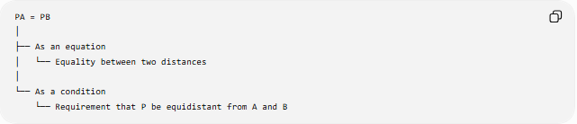
PA = PB
│
├── As an equation
│ └── Equality between two distances
│
└── As a condition
└── Requirement that P be equidistant from A and B
Thus, the same mathematical form can sometimes belong to both categories.

Geometric Equation vs Geometric Theorem
# Source: AI Source: Provided by: [Data Path: Persons Table -> ID Column: 1, Name_En Column: Motasem Essam] -> From: [ChatGPT] on [7/25/2026]
A geometric equation is not necessarily a theorem.
For example:
$$x+5=12$$
is an equation involving a geometric variable if $x$represents a length, but it is not itself a geometric theorem.
A theorem may establish a geometric equation.
For example, the Pythagorean Theorem establishes:
$$\boxed{a^{2}+b^{2}=c^{2}}$$
for the sides of a right triangle.
So:
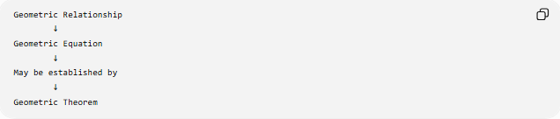
Geometric Relationship
↓
Geometric Equation
↓
May be established by
↓
Geometric Theorem

Equation Types by Mathematical Role
# Source: AI Source: Provided by: [Data Path: Persons Table -> ID Column: 1, Name_En Column: Motasem Essam] -> From: [ChatGPT] on [7/25/2026]
Another useful classification is:
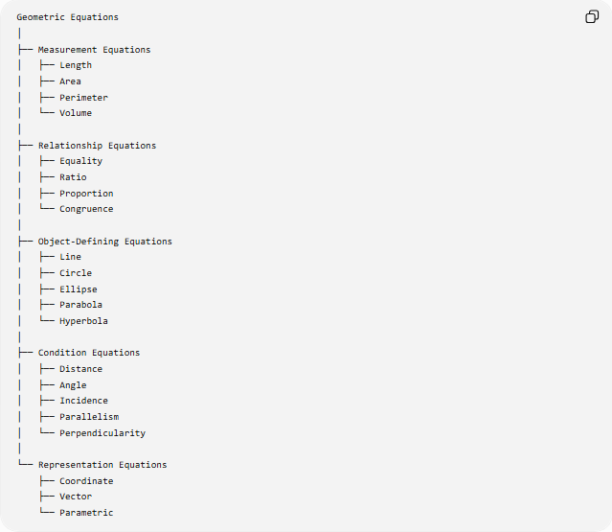
Geometric Equations
│
├── Measurement Equations
│ ├── Length
│ ├── Area
│ ├── Perimeter
│ └── Volume
│
├── Relationship Equations
│ ├── Equality
│ ├── Ratio
│ ├── Proportion
│ └── Congruence
│
├── Object-Defining Equations
│ ├── Line
│ ├── Circle
│ ├── Ellipse
│ ├── Parabola
│ └── Hyperbola
│
├── Condition Equations
│ ├── Distance
│ ├── Angle
│ ├── Incidence
│ ├── Parallelism
│ └── Perpendicularity
│
└── Representation Equations
├── Coordinate
├── Vector
└── Parametric

Important Examples
# Source: AI Source: Provided by: [Data Path: Persons Table -> ID Column: 1, Name_En Column: Motasem Essam] -> From: [ChatGPT] on [7/25/2026]
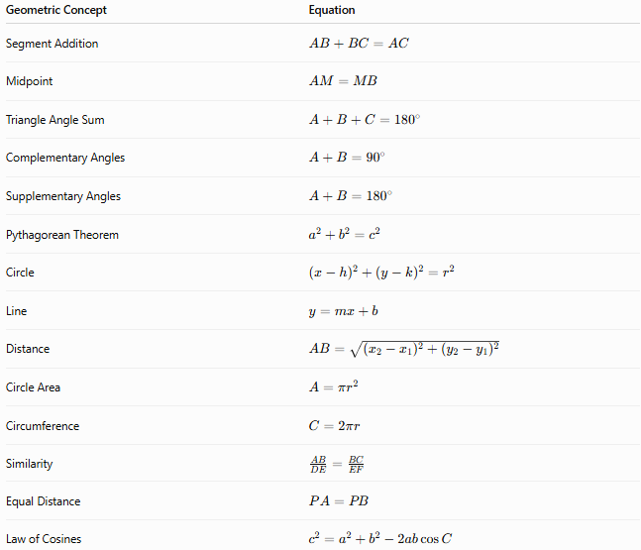
Geometric Concept | Equation
Segment Addition | $$AB+BC=AC$$
Midpoint | $$AM=MB$$
Triangle Angle Sum | $$A+B+C={180}^{∘}$$
Complementary Angles | $$A+B={90}^{∘}$$
Supplementary Angles | $$A+B={180}^{∘}$$
Pythagorean Theorem | $$a^{2}+b^{2}=c^{2}$$
Circle | $${\left(x-h\right)}^{2}+{\left(y-k\right)}^{2}=r^{2}$$
Line | $$y=mx+b$$
Distance | $$AB=\sqrt{{\left(x_{2}-x_{1}\right)}^{2}+{\left(y_{2}-y_{1}\right)}^{2}}$$
Circle Area | $$A=πr^{2}$$
Circumference | $$C=2πr$$
Similarity | $$\frac{AB}{DE}=\frac{BC}{EF}$$
Equal Distance | $$PA=PB$$
Law of Cosines | $$c^{2}=a^{2}+b^{2}-2ab\cos{C}$$

Key Characteristics
# Source: AI Source: Provided by: [Data Path: Persons Table -> ID Column: 1, Name_En Column: Motasem Essam] -> From: [ChatGPT] on [7/25/2026]
A geometric equation:
- Contains an equality relationship.
- Represents geometric quantities, objects, or relationships.
- Can contain numbers, variables, coordinates, vectors, or geometric symbols.
- Can define a geometric object.
- Can express a geometric measurement.
- Can express a geometric constraint.
- Can be used in geometric calculations.
- Can be used as part of a geometric proof.
- Can represent a locus.
- Can represent a coordinate or parametric geometric object.

Key Distinction
# Source: AI Source: Provided by: [Data Path: Persons Table -> ID Column: 1, Name_En Column: Motasem Essam] -> From: [ChatGPT] on [7/25/2026]
The relationship between the main concepts can be summarized as:
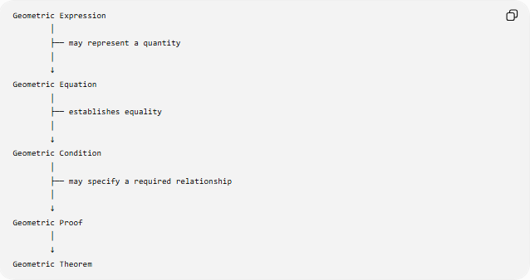
Geometric Expression
│
├── may represent a quantity
│
↓
Geometric Equation
│
├── establishes equality
│
↓
Geometric Condition
│
├── may specify a required relationship
│
↓
Geometric Proof
│
↓
Geometric Theorem
These categories can overlap depending on how the mathematical statement is being used.

Key Formula
# Source: AI Source: Provided by: [Data Path: Persons Table -> ID Column: 1, Name_En Column: Motasem Essam] -> From: [ChatGPT] on [7/25/2026]
The general structure of an equation is:
$$\boxed{\text{Left-Hand Expression}=\text{Right-Hand Expression}}$$
For geometry:
$$\boxed{{\text{Geometric Expression}}_{1}={\text{Geometric Expression}}_{2}}$$
For example:
$$\boxed{AB+BC=AC}$$
or:
$$\boxed{A=πr^{2}}$$
or:
$$\boxed{{\left(x-h\right)}^{2}+{\left(y-k\right)}^{2}=r^{2}}$$

Key Points
# Source: AI Source: Provided by: [Data Path: Persons Table -> ID Column: 1, Name_En Column: Motasem Essam] -> From: [ChatGPT] on [7/25/2026]
- A Geometric Equation represents an equality involving geometric quantities or relationships.
- It always uses an equality relationship such as $=$.
- It can represent measurements, conditions, geometric objects, or mathematical relationships.
- Coordinate equations can define lines, circles, and conic sections.
- Equations such as $PA=PB$can simultaneously serve as equations and geometric conditions.
- A geometric equation is not automatically a theorem.
- A theorem may establish an equation as universally valid under particular assumptions.
- Inequalities such as $AB>CD$are geometric inequalities, not geometric equations in the strict sense.

Conclusion
# Source: AI Source: Provided by: [Data Path: Persons Table -> ID Column: 1, Name_En Column: Motasem Essam] -> From: [ChatGPT] on [7/25/2026]
A Geometric Equation is an equality used to mathematically represent a geometric quantity, object, relationship, or constraint.
Its general form is:
$$\boxed{{\text{Geometric Expression}}_{1}={\text{Geometric Expression}}_{2}}$$
Examples include:
$$\boxed{AB+BC=AC} \\ \boxed{A=πr^{2}} \\ \boxed{a^{2}+b^{2}=c^{2}}$$
and:
$$\boxed{{\left(x-h\right)}^{2}+{\left(y-k\right)}^{2}=r^{2}}$$
Thus, geometric equations are one of the main mathematical tools for describing, calculating, analyzing, and proving geometric relationships.

